**Cookie Analysis and Manipulation Using Cookie Editor**



**Introduction**

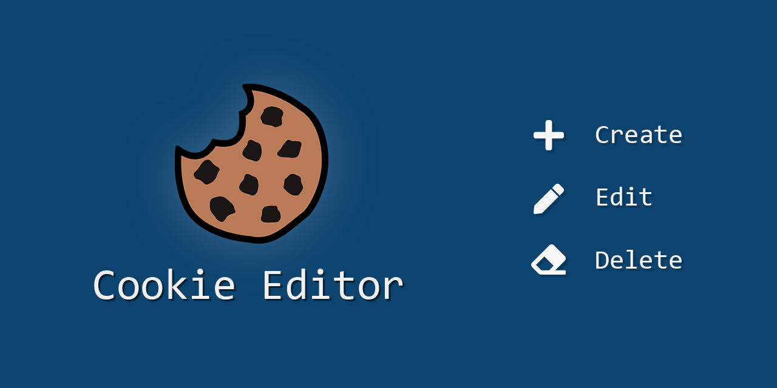

Cookies are small pieces of data sent from a website and stored on the user's computer by the user's web browser. They are used to remember information about the user, such as login details, preferences, and tracking information. This Capture the Flag (CTF) scenario introduces beginners to the basics of using the Cookie Editor extension to analyze and manipulate cookies on a given webpage.

**Scenario**

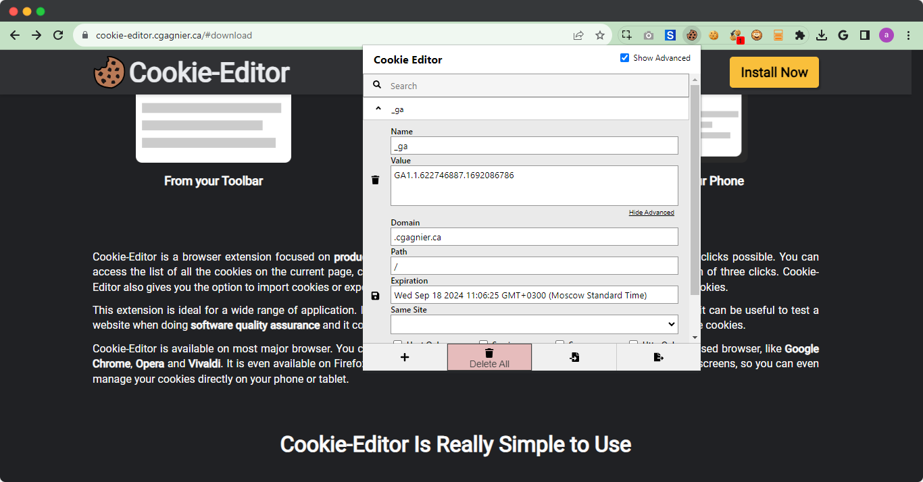

In this scenario, you will use the Cookie Editor extension to analyze and manipulate cookies on a specific webpage. Your tasks include identifying different cookies and their attributes, modifying cookies, and observing the changes to capture flags.

**Process**

Step 1: Go to the link given below and add the extension on your google chrome.

Step 2: Open the cookie editor which can be opened by clicking on the small box which was present on the top right corner of your pc screen.

<https://chromewebstore.google.com/detail/cookie-editor/hlkenndednhfkekhgcdicdfddnkalmdm>

Step 3: Open wikipedia: <https://www.wikipedia.org/>

**Questions**

**Flag 1: How many cookies are set by the Wikipedia homepage?**

Answer: 4

Flag Captured.

**Flag 2: What is the value of NetworkProbelLimit?**

Answer: 0.001

Flag Captured.

**Hint**:

